1. **Preparing Python**

Uninstall “python” and “python launcher” from the Control Panel. (If you have python installed beforehand.)

Download miniconda and install <https://docs.conda.io/en/latest/miniconda.html>

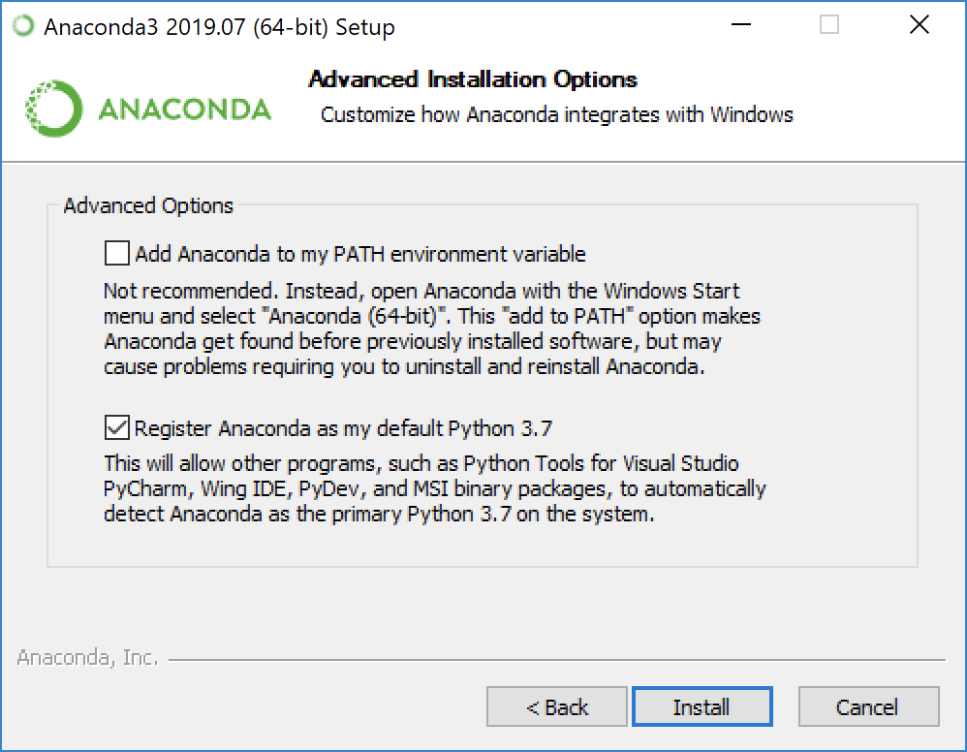

When asked, click that check box.(add anaconda to my PATH…)

1. **Installing CUDA Libraries**

Head over to this site, download and install the cuda toolkit

<https://developer.nvidia.com/cuda-downloads?target_os=Windows&target_arch=x86_64&target_version=10&target_type=exelocal>

the config:

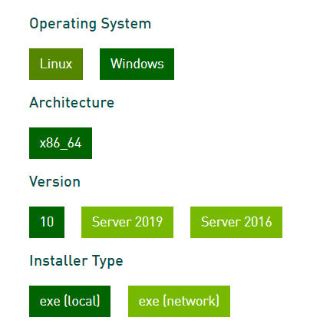

1. **Download cudnn from drive**

* Extract it and copy the “cuda” folder.
* Create new folder in C:\ with name “tools” and paste inside it
* Go to desktop ,Right click “this pc”
* Properties=> Advanced System Settings=> Environment variables
* Scroll down and **double click** “Path”

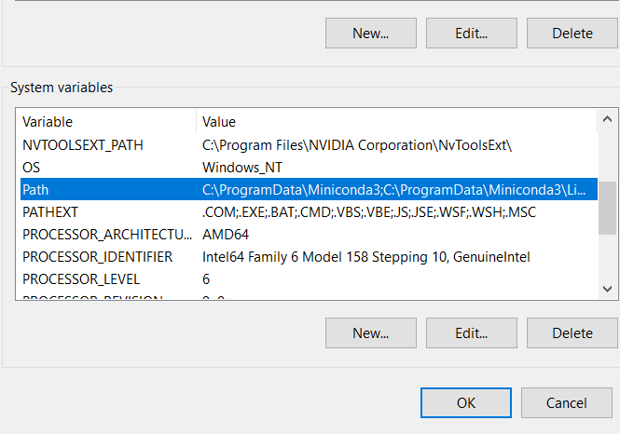

* Click new button
* Paste “C:\tools\cuda\bin” click ok and close it

1. **Setting up the Project Files**

* Download and Extract the rar file.
* Inside the directory, open a python file named predict.
* In main function check for the place where it denotes image path and change the image name in that place or change the name of the image in directory.
* Save that python file and exit.
* Copy the directory path.
* Example:

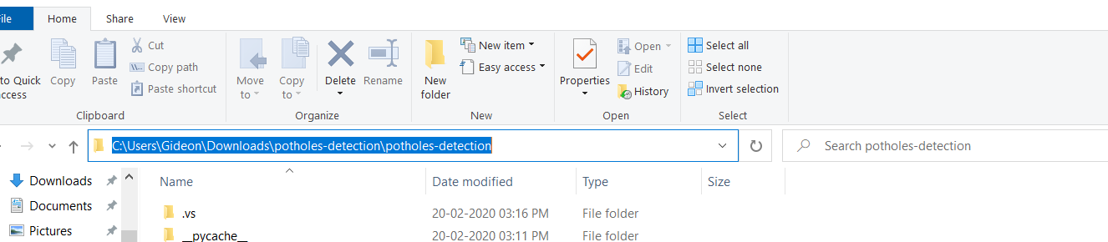

* Get back to cmd and execute the following stuff one by one
* cd “directory u copied”

Or just go to the directory and type cmd in the address bar.

1. **Installing required modules**

* Open command prompt with admin privileges
* Execute upcoming commands one by one
* conda create --name tf-gpu



* (press y and enter)

conda activate tf-gpu

* Installing tensorflow:
* conda install tensorflow-gpu
* (press y and enter)
* To verify tensorflow installation type:

python

* Type the code

import tensorflow as tf

print(tf.__version__)

* Installing Keras:

conda install keras

* (press y and enter)
* Installing Opencv:

conda install opencv

* (press y and enter)
* Installing Imgaug:

conda config --add channels conda-forge

conda install imgaug

(press y and enter)

conda install tqdm

(press y and enter)

* python predict.py
* wait for it to complete and check the directory
* To Exit console press ctrl+Z

